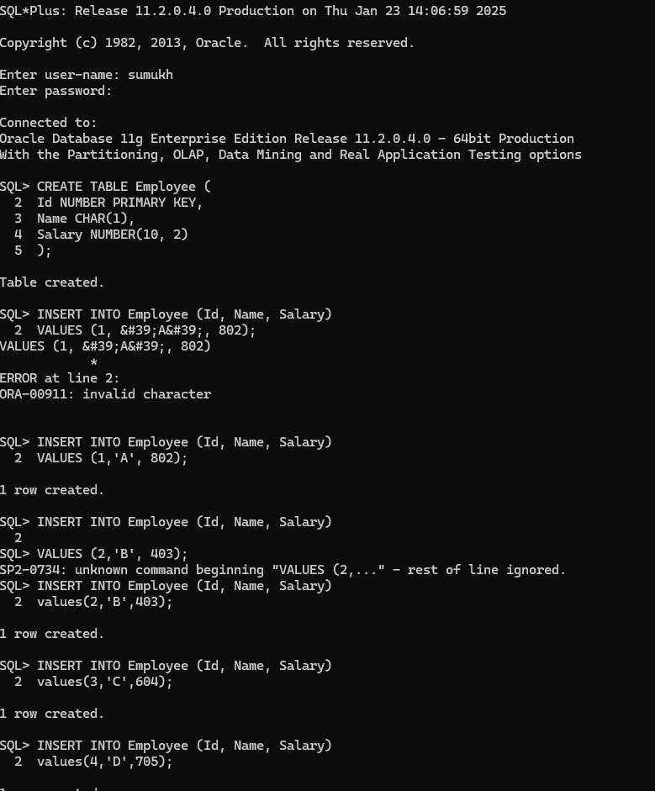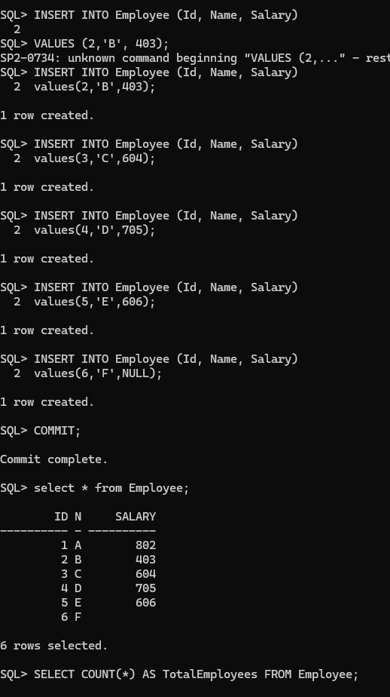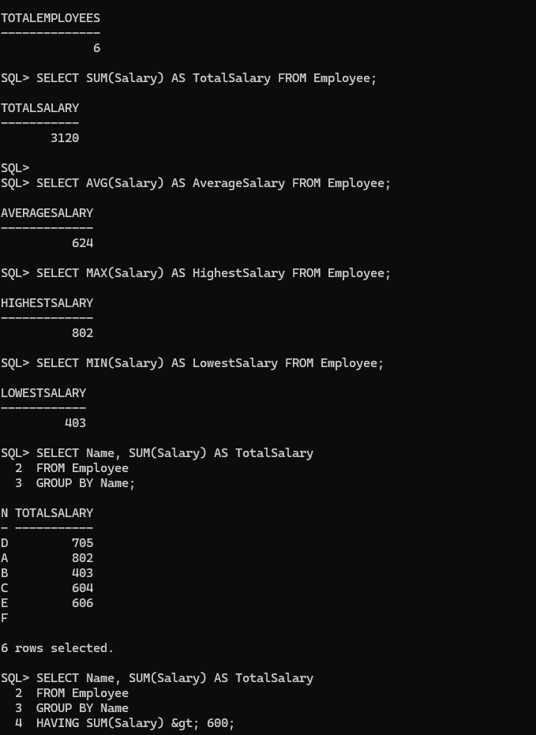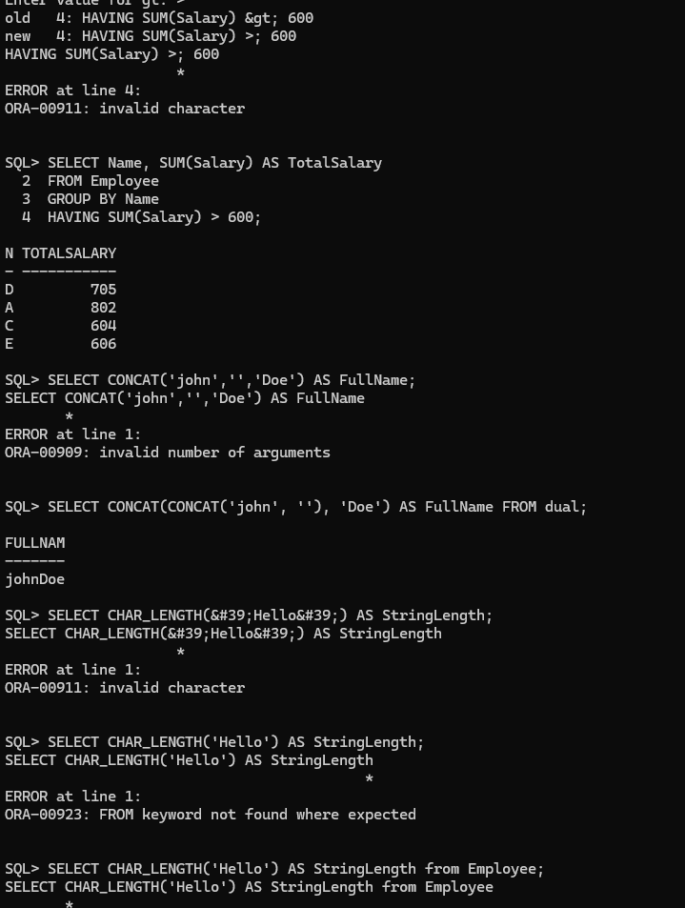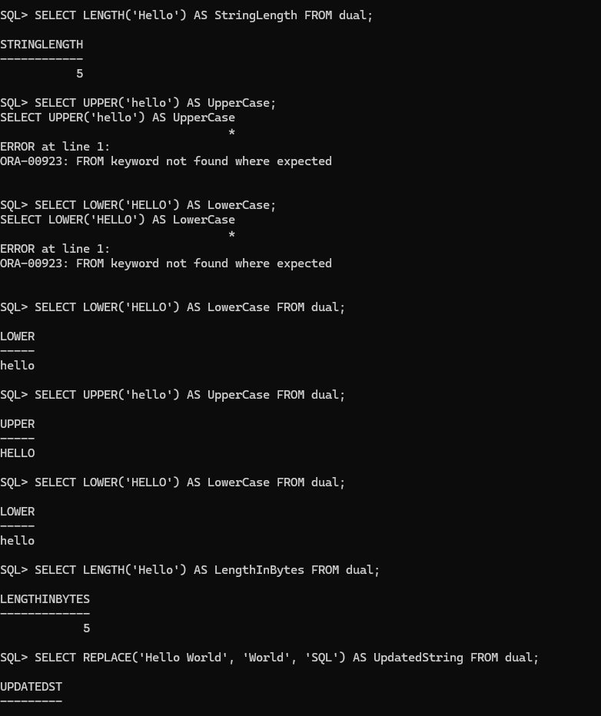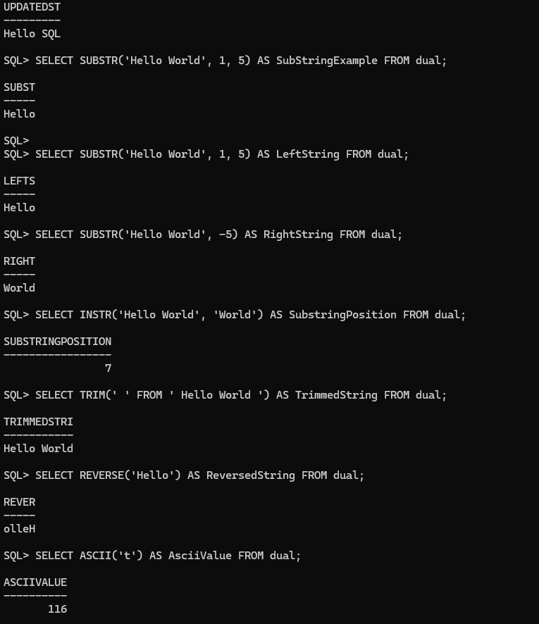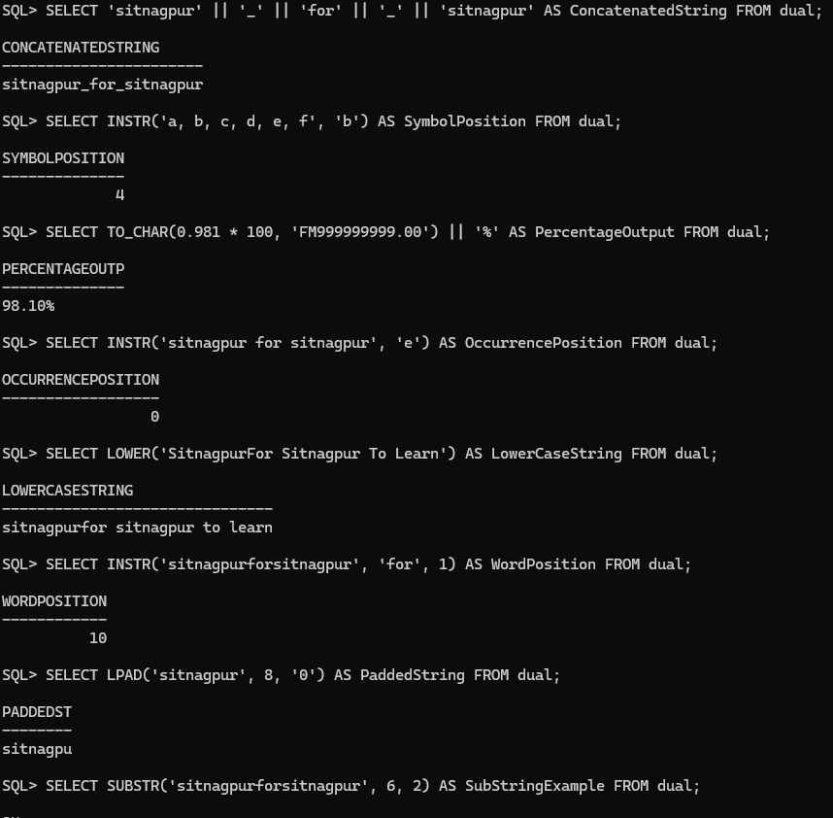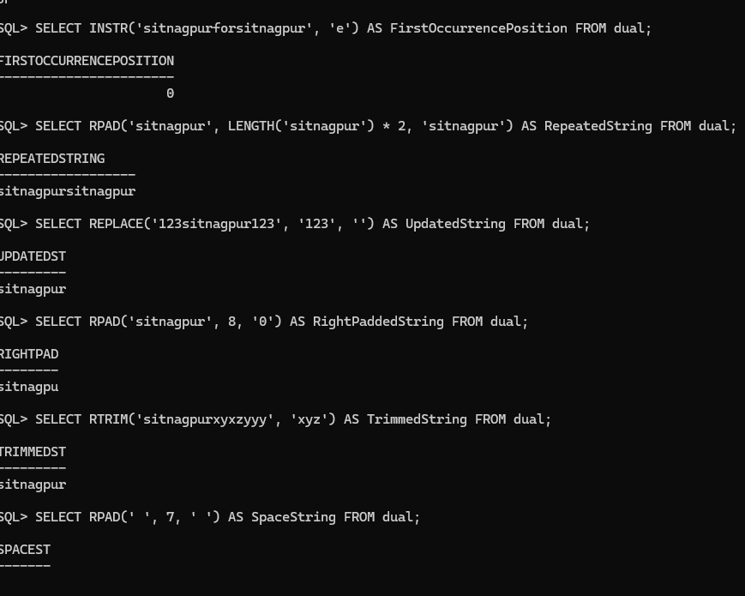SQL*Plus: Release 11.2.0.4.0 Production on Thu Jan 23 14:06:59 2025

Copyright (c) 1982, 2013, Oracle. All rights reserved.

Enter user-name: sumukh

Enter password:

Connected to:

Oracle Database 11g Enterprise Edition Release 11.2.0.4.0 - 64bit Production

With the Partitioning, OLAP, Data Mining and Real Application Testing options

SQL> CREATE TABLE Employee (

2 Id NUMBER PRIMARY KEY,

3 Name CHAR(1),

4 Salary NUMBER(10, 2)

5 );

Table created.

SQL> INSERT INTO Employee (Id, Name, Salary)

2 VALUES (1, &#39;A&#39;, 802);

VALUES (1, &#39;A&#39;, 802)

*

ERROR at line 2:

ORA-00911: invalid character

SQL> INSERT INTO Employee (Id, Name, Salary)

2 VALUES (1,'A', 802);

1 row created.

SQL> INSERT INTO Employee (Id, Name, Salary)

2

SQL> VALUES (2,'B', 403);

SP2-0734: unknown command beginning "VALUES (2,..." - rest of line ignored.

SQL> INSERT INTO Employee (Id, Name, Salary)

2 values(2,'B',403);

1 row created.

SQL> INSERT INTO Employee (Id, Name, Salary)

2 values(3,'C',604);

1 row created.

SQL> INSERT INTO Employee (Id, Name, Salary)

2 values(4,'D',705);

1 row created.

SQL> INSERT INTO Employee (Id, Name, Salary)

2 values(5,'E',606);

1 row created.

SQL> INSERT INTO Employee (Id, Name, Salary)

2 values(6,'F',NULL);

1 row created.

SQL> COMMIT;

Commit complete.

SQL> select * from Employee;

ID N SALARY

---------- - ----------

1 A 802

2 B 403

3 C 604

4 D 705

5 E 606

6 F

6 rows selected.

SQL> SELECT COUNT(*) AS TotalEmployees FROM Employee;

TOTALEMPLOYEES

--------------

6

SQL> SELECT SUM(Salary) AS TotalSalary FROM Employee;

TOTALSALARY

-----------

3120

SQL>

SQL> SELECT AVG(Salary) AS AverageSalary FROM Employee;

AVERAGESALARY

-------------

624

SQL> SELECT MAX(Salary) AS HighestSalary FROM Employee;

HIGHESTSALARY

-------------

802

SQL> SELECT MIN(Salary) AS LowestSalary FROM Employee;

LOWESTSALARY

------------

403

SQL> SELECT Name, SUM(Salary) AS TotalSalary

2 FROM Employee

3 GROUP BY Name;

N TOTALSALARY

- -----------

D 705

A 802

B 403

C 604

E 606

F

6 rows selected.

SQL> SELECT Name, SUM(Salary) AS TotalSalary

2 FROM Employee

3 GROUP BY Name

4 HAVING SUM(Salary) &gt; 600;

Enter value for gt: >

old 4: HAVING SUM(Salary) &gt; 600

new 4: HAVING SUM(Salary) >; 600

HAVING SUM(Salary) >; 600

*

ERROR at line 4:

ORA-00911: invalid character

SQL> SELECT Name, SUM(Salary) AS TotalSalary

2 FROM Employee

3 GROUP BY Name

4 HAVING SUM(Salary) > 600;

N TOTALSALARY

- -----------

D 705

A 802

C 604

E 606

SQL> SELECT CONCAT('john','','Doe') AS FullName;

SELECT CONCAT('john','','Doe') AS FullName

*

ERROR at line 1:

ORA-00909: invalid number of arguments

SQL> SELECT CONCAT(CONCAT('john', ''), 'Doe') AS FullName FROM dual;

FULLNAM

-------

johnDoe

SQL> SELECT CHAR_LENGTH(&#39;Hello&#39;) AS StringLength;

SELECT CHAR_LENGTH(&#39;Hello&#39;) AS StringLength

*

ERROR at line 1:

ORA-00911: invalid character

SQL> SELECT CHAR_LENGTH('Hello') AS StringLength;

SELECT CHAR_LENGTH('Hello') AS StringLength

*

ERROR at line 1:

ORA-00923: FROM keyword not found where expected

SQL> SELECT CHAR_LENGTH('Hello') AS StringLength from Employee;

SELECT CHAR_LENGTH('Hello') AS StringLength from Employee

*

ERROR at line 1:

ORA-00904: "CHAR_LENGTH": invalid identifier

SQL> SELECT CHAR_LENGTH('Hello') AS StringLength from Employee;

SELECT CHAR_LENGTH('Hello') AS StringLength from Employee

*

ERROR at line 1:

ORA-00904: "CHAR_LENGTH": invalid identifier

SQL> SELECT CHAR_LENGTH('Hello') AS StringLength FROM dual;

SELECT CHAR_LENGTH('Hello') AS StringLength FROM dual

*

ERROR at line 1:

ORA-00904: "CHAR_LENGTH": invalid identifier

SQL> SELECT CHAR_LENGTH('Hello') AS StringLength FROM Employee;

SELECT CHAR_LENGTH('Hello') AS StringLength FROM Employee

*

ERROR at line 1:

ORA-00904: "CHAR_LENGTH": invalid identifier

SQL> SELECT CHAR_LENGTH('Hello') AS StringLength;

SELECT CHAR_LENGTH('Hello') AS StringLength

*

ERROR at line 1:

ORA-00923: FROM keyword not found where expected

SQL> SELECT CHAR_LENGTH('Hello') AS StringLength FROM dual;

SELECT CHAR_LENGTH('Hello') AS StringLength FROM dual

*

ERROR at line 1:

ORA-00904: "CHAR_LENGTH": invalid identifier

SQL> SELECT LENGTH('Hello') AS StringLength FROM dual;

STRINGLENGTH

------------

5

SQL> SELECT UPPER('hello') AS UpperCase;

SELECT UPPER('hello') AS UpperCase

*

ERROR at line 1:

ORA-00923: FROM keyword not found where expected

SQL> SELECT LOWER('HELLO') AS LowerCase;

SELECT LOWER('HELLO') AS LowerCase

*

ERROR at line 1:

ORA-00923: FROM keyword not found where expected

SQL> SELECT LOWER('HELLO') AS LowerCase FROM dual;

LOWER

-----

hello

SQL> SELECT UPPER('hello') AS UpperCase FROM dual;

UPPER

-----

HELLO

SQL> SELECT LOWER('HELLO') AS LowerCase FROM dual;

LOWER

-----

hello

SQL> SELECT LENGTH('Hello') AS LengthInBytes FROM dual;

LENGTHINBYTES

-------------

5

SQL> SELECT REPLACE('Hello World', 'World', 'SQL') AS UpdatedString FROM dual;

UPDATEDST

---------

Hello SQL

SQL> SELECT SUBSTR('Hello World', 1, 5) AS SubStringExample FROM dual;

SUBST

-----

Hello

SQL>

SQL> SELECT SUBSTR('Hello World', 1, 5) AS LeftString FROM dual;

LEFTS

-----

Hello

SQL> SELECT SUBSTR('Hello World', -5) AS RightString FROM dual;

RIGHT

-----

World

SQL> SELECT INSTR('Hello World', 'World') AS SubstringPosition FROM dual;

SUBSTRINGPOSITION

-----------------

7

SQL> SELECT TRIM(' ' FROM ' Hello World ') AS TrimmedString FROM dual;

TRIMMEDSTRI

-----------

Hello World

SQL> SELECT REVERSE('Hello') AS ReversedString FROM dual;

REVER

-----

olleH

SQL> SELECT ASCII('t') AS AsciiValue FROM dual;

ASCIIVALUE

----------

116

SQL> SELECT CONCAT_WS('_', 'sitnagpur', 'for', 'sitnagpur') AS ConcatenatedString FROM dual;

SELECT CONCAT_WS('_', 'sitnagpur', 'for', 'sitnagpur') AS ConcatenatedString FROM dual

*

ERROR at line 1:

ORA-00904: "CONCAT_WS": invalid identifier

SQL> SELECT FIND_IN_SET('b', 'a, b, c, d, e, f') AS SymbolPosition FROM dual;

SELECT FIND_IN_SET('b', 'a, b, c, d, e, f') AS SymbolPosition FROM dual

*

ERROR at line 1:

ORA-00904: "FIND_IN_SET": invalid identifier

SQL> SELECT 'sitnagpur' || '_' || 'for' || '_' || 'sitnagpur' AS ConcatenatedString FROM dual;

CONCATENATEDSTRING

-----------------------

sitnagpur_for_sitnagpur

SQL> SELECT INSTR('a, b, c, d, e, f', 'b') AS SymbolPosition FROM dual;

SYMBOLPOSITION

--------------

4

SQL> SELECT TO_CHAR(0.981 * 100, 'FM999999999.00') || '%' AS PercentageOutput FROM dual;

PERCENTAGEOUTP

--------------

98.10%

SQL> SELECT INSTR('sitnagpur for sitnagpur', 'e') AS OccurrencePosition FROM dual;

OCCURRENCEPOSITION

------------------

0

SQL> SELECT LOWER('SitnagpurFor Sitnagpur To Learn') AS LowerCaseString FROM dual;

LOWERCASESTRING

-------------------------------

sitnagpurfor sitnagpur to learn

SQL> SELECT INSTR('sitnagpurforsitnagpur', 'for', 1) AS WordPosition FROM dual;

WORDPOSITION

------------

10

SQL> SELECT LPAD('sitnagpur', 8, '0') AS PaddedString FROM dual;

PADDEDST

--------

sitnagpu

SQL> SELECT SUBSTR('sitnagpurforsitnagpur', 6, 2) AS SubStringExample FROM dual;

SU

--

gp

SQL> SELECT INSTR('sitnagpurforsitnagpur', 'e') AS FirstOccurrencePosition FROM dual;

FIRSTOCCURRENCEPOSITION

-----------------------

0

SQL> SELECT RPAD('sitnagpur', LENGTH('sitnagpur') * 2, 'sitnagpur') AS RepeatedString FROM dual;

REPEATEDSTRING

------------------

sitnagpursitnagpur

SQL> SELECT REPLACE('123sitnagpur123', '123', '') AS UpdatedString FROM dual;

UPDATEDST

---------

sitnagpur

SQL> SELECT RPAD('sitnagpur', 8, '0') AS RightPaddedString FROM dual;

RIGHTPAD

--------

sitnagpu

SQL> SELECT RTRIM('sitnagpurxyxzyyy', 'xyz') AS TrimmedString FROM dual;

TRIMMEDST

---------

sitnagpur

SQL> SELECT RPAD(' ', 7, ' ') AS SpaceString FROM dual;

SPACEST

-------

SQL>